**Site navigation refactored and improved**

**Desktop**

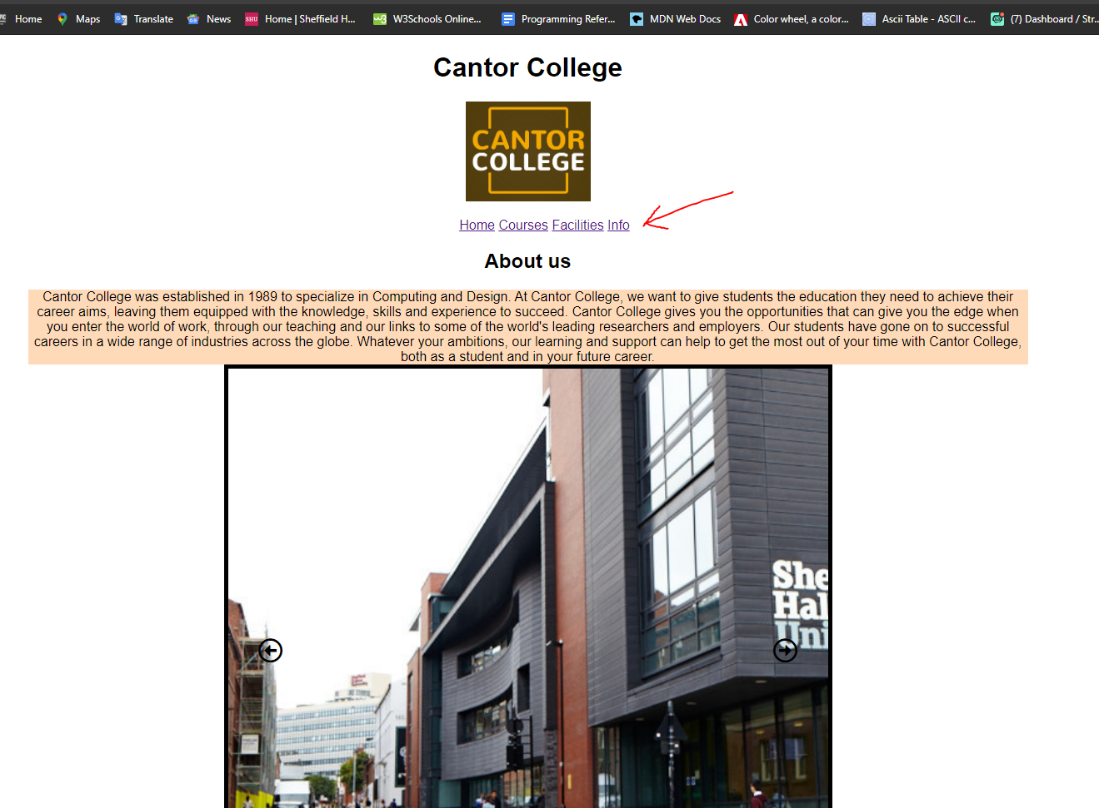

In the desktop version of my website, I saw no real need to add a burger menu or any way to refactor the navigation due to the space I had. So, I thought it would be appropriate to leave the nav the only thing I did was use ‘display inline’ so the links appear in line rather than bullet points.

**Mobile**

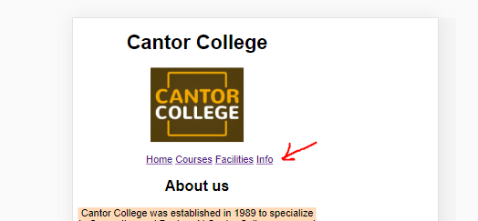

However, in the mobile version of my website I was an opportunity to use a burger menu and the reasoning for this was because it would be more familiar to users as the burger menu is commonly used among other apps and websites, furthermore it gives is a better and more cleaner looking aesthetic.

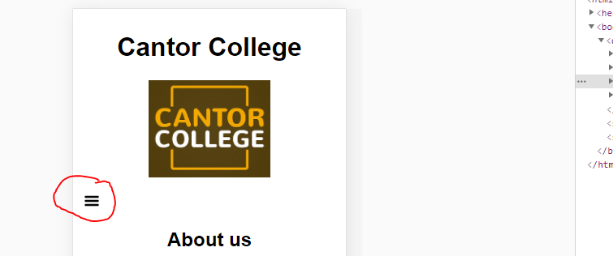

Here is my website in mobile view.

When the burger menu is clicked on the menu will use this jQuery as a to cause a transition

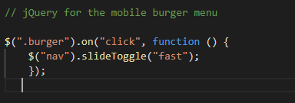

Which will then result in the nav being revealed.

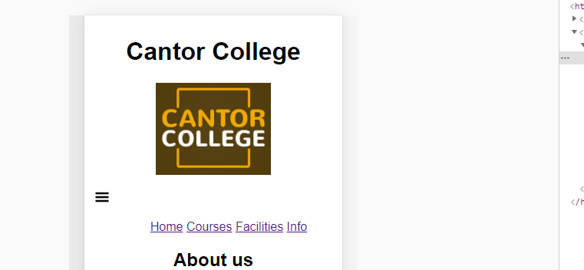

The mobile view of the website is now more aesthetically pleasing and easier for the user to navigate.